Electrical Automation Technology, Control Systems Technology & Electrical Systems Design Technology
Performance Test Final

Name _________________________ Instructor Verification __________ Grade __________

Material:
Materials Provided by You | Materials Provided by the Department
1. Necessary Tools | 1. Two Three-Way Switches
2. 14/2 w/Ground NM-B or MC Cable | 2. GFCI Receptacle
3. 14/3 w/Ground NM-B or MC Cable | 3. Lamp Holder
4. Wire Kit | 4. Receptacle

Objective:
Given necessary materials, the student will construct an electrical circuit in 60 minutes, as evidenced by scoring a minimum of 75% on this test.

Description of the Circuit:
Construct a circuit in which a lamp holder is controlled from two locations. The duplex and GFCI receptacles are “hot” at all time. Power is fed to the luminaire box. The duplex receptacle is protected by the GFCI receptacle. All conductors must be used (termination or splice). All devices and lamp are installed in metal boxes.

Time Limit:
You are allowed 60 minutes to complete the circuit. Ten points for every five minutes over the allotted time will be deducted from the score. The maximum overtime allowed is fifteen minutes.

Part 1 (+20 points)
Using a straight edge, draw how this circuit will be wired.
Start Time___________ Finish Time__________

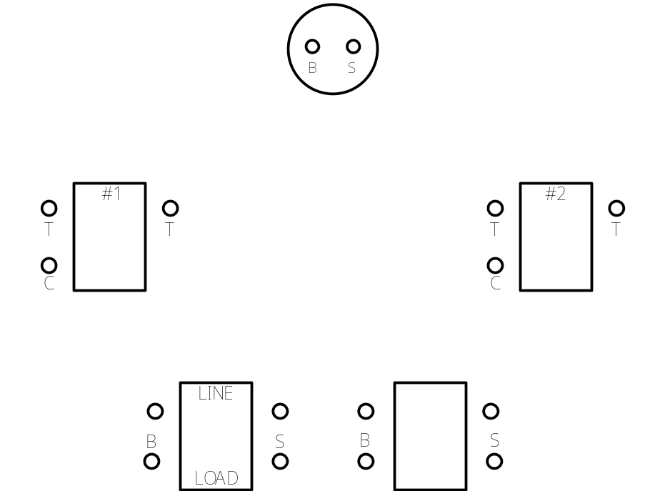
Performance Test Final

Part #2 (80 points):

Construct the circuit.

__________ Circuit wired to NEC. +10 points

__________ Wire nut connections secure. +10 points

__________ Conductors on device correctly. +10 points

____________ 6” of free conductor from the edge of the box. +5 points

____________ 1/4" of cable sheath inside the box. +5 points (if NM-B is used)

____________ All anti-short bushing in place. +5 points (if MC is used)

____________ Circuit works as described. +40 points (troubleshooting yourself +15 points)

